Practical No. 1
Definition : Write a program to create a class and object in Python.
Aim/ Objective:
- To understand the concept of classes and objects in Python.
- To learn how to define a class with data members and methods.
- To create objects and access class members using objects.
- To understand the basics of object-oriented programming in Python.

Source Code:
class Student:
def display(self):
print("Hello, I am a student.")

s1 = Student()
s1.display()

Output:
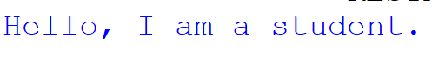
Conclusion:
Thus, a class and object were created successfully in Python. The program demonstrated how to define a class, create an object, and call a method using that object.

Practical No. 2
Definition :Write a program to demonstrate constructor and destructor usage.
Aim/ Objective:
- To understand the use of constructors and destructors in Python.
- To learn how the __init__() method initializes an object.
- To demonstrate the use of the __del__() method when an object is destroyed.
- To understand object initialization and cleanup in Python.

Source Code:
class Student:
def __init__(self):
print("Constructor called")

def __del__(self):
print("Destructor called")

s1 = Student()
del s1

Output:
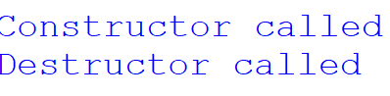
Conclusion:
Thus, constructor and destructor usage was demonstrated successfully in Python. The program showed how the constructor initializes an object and how the destructor may be called when the object is destroyed.

Practical No. 3
Definition :Write a program to illustrate instance variables and class variables.
Aim/ Objective:
- To understand the difference between instance variables and class variables in Python.
- To learn how instance variables store individual object data.
- To demonstrate how class variables are shared among all objects of a class.
- To access and display instance and class variable values.

Source Code:
class Student:
college = "Marwadi University"

def __init__(self, name, age):
self.name = name
self.age = age

s1 = Student("Harshitha", 20)
s2 = Student("Priya", 21)

print("Student 1:", s1.name, s1.age)
print("Student 2:", s2.name, s2.age)
print("College:", Student.college)

Output:
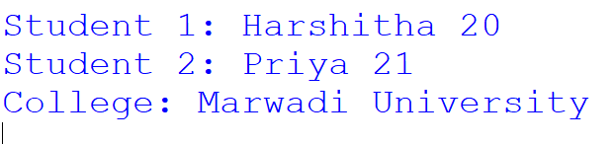

Conclusion:
Thus, instance variables and class variables were demonstrated successfully in Python. The program showed that instance variables store separate data for each object, while class variables are shared among all objects of the class.

Practical No. 4
Definition : Write a program to demonstrate instance methods, class methods, and static methods.
Aim/ Objective:
- To understand different types of methods in Python classes.
- To demonstrate instance methods using the self parameter.
- To learn how class methods use the cls parameter to access class variables.
- To demonstrate static methods for performing operations without accessing instance or class-specific data.

Source Code:
class Student:
college = "Marwadi University"

def instance_method(self):
print("This is an instance method.")

@classmethod
def class_method(cls):
print("College:", cls.college)

@staticmethod
def static_method():
print("This is a static method.")

s1 = Student()

s1.instance_method()
Student.class_method()
Student.static_method()

Output:
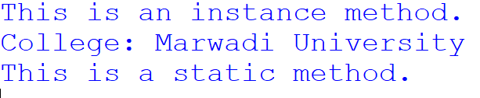
Conclusion:
Thus, instance methods, class methods, and static methods were demonstrated successfully in Python. The program explained how each method is defined and used to perform different operations within a class.

Practical No. 5
Definition :Write a program to implement single multilevel and multiple inheritance.
Aim/ Objective:
- To understand the concept of inheritance in Python.
- To implement single inheritance, where one child class inherits from one parent class.
- To implement multilevel inheritance, where a class inherits from a derived class.
- To implement multiple inheritance, where one child class inherits from more than one parent class.
Source Code:
# Single Inheritance
class A:
def display_A(self):
print("This is class A")

class B(A):
def display_B(self):
print("This is class B")

print("Single Inheritance:")
obj1 = B()
obj1.display_A()
obj1.display_B()

# Multilevel Inheritance
class C:
def display_C(self):
print("This is class C")

class D(C):
def display_D(self):
print("This is class D")

class E(D):
def display_E(self):
print("This is class E")

print("\nMultilevel Inheritance:")
obj2 = E()
obj2.display_C()
obj2.display_D()
obj2.display_E()

# Multiple Inheritance
class F:
def display_F(self):
print("This is class F")
class G:
def display_G(self):
print("This is class G")

class H(F, G):
def display_H(self):
print("This is class H")

print("\nMultiple Inheritance:")

obj3 = H()
obj3.display_F()
obj3.display_G()
obj3.display_H()
Output:
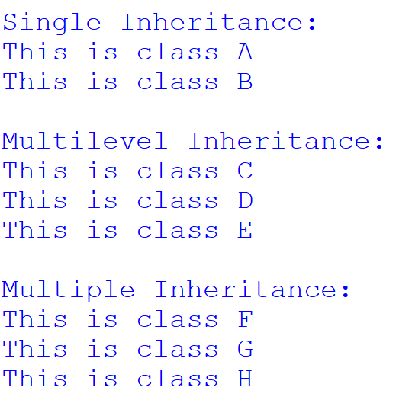

Conclusion: Thus, single, multilevel, and multiple inheritance were implemented successfully in Python. The program demonstrated how a child class can inherit methods and properties from one or more parent classes, promoting code reusability and reducing code duplication.
Practical No. 6
Definition : Write a python program to demonstrate method overriding and polymorphism.
Aim/ Objective:
- To understand the concepts of method overriding and polymorphism in Python.
- To demonstrate method overriding by redefining a parent class method in a child class.
- To implement polymorphism by using the same method name for different classes.
- To understand how the same method can perform different actions depending on the object.

Source Code:
class Animal:
def sound(self):
print("Animal makes a sound")

class Dog(Animal):
def sound(self):
print("Dog barks")

class Cat(Animal):
def sound(self):
print("Cat meows")

a = Animal()
d = Dog()
c = Cat()

a.sound()
d.sound()
c.sound()

Output:
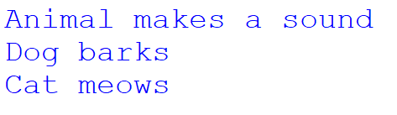

Conclusion:
Thus, method overriding and polymorphism were demonstrated successfully in Python. The program showed how child classes can redefine parent class methods and how the same method name produces different outputs depending on the object.

Practical No. 7
Definition :Write a program to illustrate method resolution order and magic methods.
Aim/ Objective:
- To understand the concept of Method Resolution Order (MRO) in Python.
- To learn how Python determines the order of method execution in inheritance.
- To demonstrate magic methods such as __init__() and __str__().
- To understand how magic methods provide special behavior to Python objects.
Source Code:
# Demonstration of MRO
class A:
def show(self):
print("Class A")

class B(A):
def show(self):
print("Class B")

class C(A):
def show(self):
print("Class C")

class D(B, C):
Pass
obj = D()
obj.show()

print("MRO:", [cls.__name__ for cls in D.mro()])

# Demonstration of Magic Methods
class Student:
def __init__(self, name):
self.name = name

def __str__(self):
return "Student Name: " + self.name

s = Student("Harshitha”)
print(s)

Output:
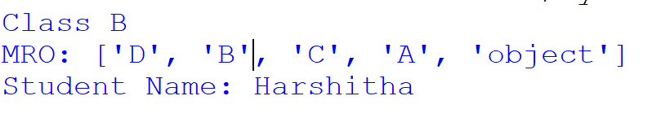
Conclusion:
Thus, Method Resolution Order and magic methods were demonstrated successfully in Python. The program showed how Python determines the orderof method lookup in inheritance and how magic methods such as__init__() and __str__() control object initialization and string representation.
Practical No. 8
Definition :Write a program to demonstrate basic regular expression pattern matching.
Aim/ Objective:
- To understand the concepts of encapsulation and abstraction in Python.
- To demonstrate encapsulation by restricting direct access to class data.
- To implement abstraction using abstract classes and abstract methods.
- To understand how these concepts improve data security and code organization.

Source Code:
from abc import ABC, abstractmethod

# Encapsulation
class BankAccount:
def __init__(self, balance):
self.__balance = balance

def show_balance(self):
print("Balance:", self.__balance)

# Abstraction
class Animal(ABC):
@abstractmethod
def sound(self):
pass

class Dog(Animal):
def sound(self):
print("Dog barks")

# Demonstration
account = BankAccount(5000)
account.show_balance()

dog = Dog()
dog.sound()

Output:
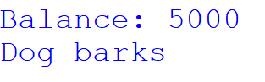

Conclusion:
Thus, encapsulation and abstraction were demonstrated successfully using Python classes. Encapsulation helps protect data from direct access, while abstraction hides implementation details and defines essential methods through abstract classes.

Practical No. 9
Definition : Write a program to read and write data into a file using different file modes.
Aim/ Objective:
- To understand file handling operations in Python.
- To learn how to read and write data into a file using different file modes.
- To demonstrate file modes such as r, w, a, and r+.
- To understand how to open, read, write, and close files in Python.

Source Code:
# Write data into a file
f = open("sample.txt", "w")
f.write("Hello, Python!\n")
f.write("File handling example.")
f.close()

# Read data from a file
f = open("sample.txt", "r")
print("File content:")
print(f.read())
f.close()

# Append data to a file
f = open("sample.txt", "a")
f.write("\nThis is appended data.")
f.close()

# Read updated data
f = open("sample.txt", "r")
print("\nUpdated file content:")
print(f.read())
f.close()

Output:
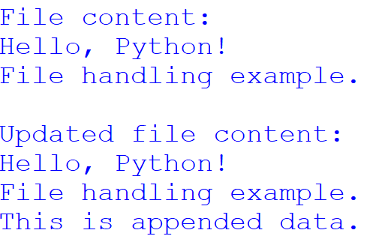

Conclusion:
Thus, reading and writing data into a file using different file modes were demonstrated successfully in Python. The program showed how to create, read, and append data to a file using the appropriate file modes.

Practical No. 10
Definition : Write a python program to perform file pointer operations using seek and tell methods.
Aim/ Objective:
- To understand file pointer operations in Python.
- To learn the use of the tell() method to find the current file pointer position.
- To demonstrate the seek() method to move the file pointer to a specific position.
- To understand how file pointers control reading and writing operations in a file.
Source Code:
f = open("sample.txt", "w")
f.write("Hello Python")
f.close()

f = open("sample.txt", "r")

print("Current position:", f.tell())

data = f.read(5)
print("Read data:", data)

print("Current position:", f.tell())

f.seek(0)
print("Position after seek:", f.tell())

print("Complete data:", f.read())

f.close()

Output:
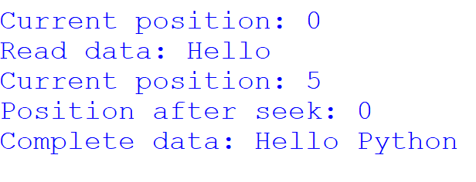

Conclusion:
Thus, file pointer operations were performed successfully using the seek() and tell() methods in Python. The program demonstrated how to check the current file pointer position and move it to a desired location for reading data.

